Rice University Data Analysis and Visualization Boot Camp

Project 1

**What Affects the Price of Electricity within the United States?**

Group Members:

Gabriel Pivaro | Jocelyn Flores | Joshua Rhoads | Justin Chow | Kimberly Flores

September 22, 2020

Contents

Introduction 3

Price Overview 3

Fig. 1 – Electricity Price by State 3

Fig. 2 – Histogram of Electricity Price in the United States 4

Fig. 3 – Box plot of Electricity Price in the United States 4

Price vs Population 5

Fig. 4 – State population (left) and highlight of state electricity price (right) 5

Fig. 5 – Scatter plot of price vs population (left) and population histogram (right) 6

Price vs Number of Power Plants 6

Fig. 6 – Power plants by state (left) and electricity price (right) 6

Fig. 7 – Power plants distribution (left) and scatter plot of price vs power plants (right) 7

Price vs Production 7

Fig. 8 –Electricity generation (left) and scatter plot of price vs electricity generation (right) 7

Price vs Overall Consumption 8

Fig. 9 –Electricity consumption by state 8

Fig. 10 –Scatter plot of price vs electricity consumption (right) 9

Price vs Regulated/Non-regulated Sources 9

Fig. 11 –Comparison of electricity price over the years of regulated and de-regulated states 10

Fig. 12 –Scatter plot of electricity price over the years of regulated and de-regulated states 11

Conclusion 12

Data Sources 12

# Introduction

Given the disperse nature of the United States, many factors could potentially impact prices for electricity. Throughout the years, electricity demand increases accordingly. Each state meets its demands differently, which are the factors that contribute to this the most? This project examines some of the larger aspects to see if there is a relation to price.

# Price Overview

In this section, we present an overview of the electricity prices in the United States. Fig. 1 presents the electricity price state by state including major types of utility customers (residential, commercial, industrial and transportation). The price is given in cents kilowatthour (kWh).

## Fig. 1 – Electricity Price by State

The histogram with the electricity price distribution is shown in Fig. 2. The average price is 11.20 cents per kWh. Notice that over 25 states have electricity prices below the average and around 13 have average prices.

## Fig. 2 – Histogram of Electricity Price in the United States

Following the distribution prices presented in the histogram, the Fig. 3 presents the box plot with the electricity prices by state. Notice that are prices of several states included as outliers.

## Fig. 3 – Box plot of Electricity Price in the United States

In the next sections we will present an analysis of some aspects and their relationship with the electricity price.

# Price vs Population

The first comparison performed analyzed the price as compared to the population. As seen in Fig. 4, the most populous states are California, Texas, and Florida. When compared to the price of electricity, California and many states in New England are the most expensive.

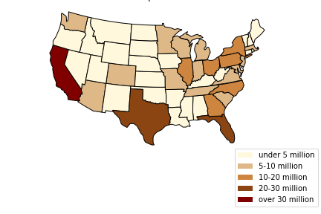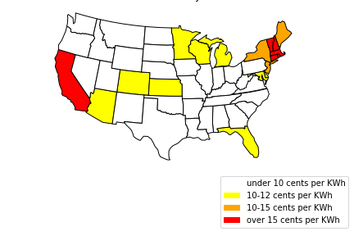

## Fig. 4 – State population (left) and highlight of state electricity price (right)

When compared to each other, a very weak correlation (r = 0.02) was found, as can be seen on the left side of Fig. 5. **Overall**, **population does not seem to affect the price of electricity** on a state by state basis. Additionally, the population itself was analyzed to see if there has been any statistical significance over time, but this also has been shown to be negative; the population has maintained relatively the same shape over the last ten years, as shown on the right side of Fig. 5.

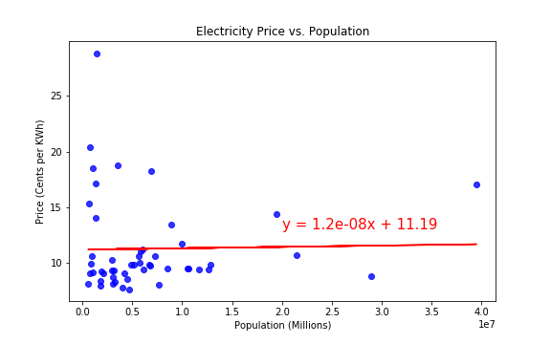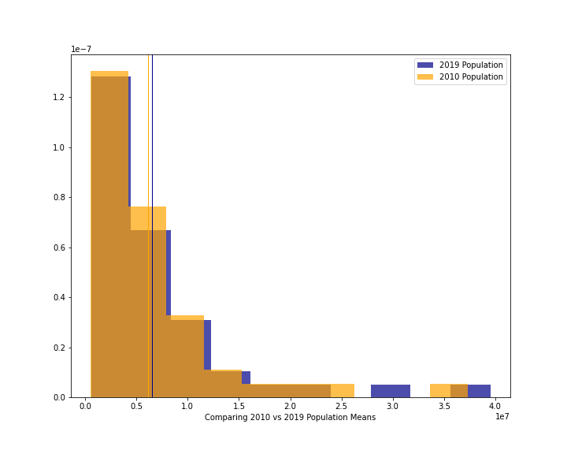

## Fig. 5 – Scatter plot of price vs population (left) and population histogram (right)

# Price vs Number of Power Plants

Fig. 6 shows the number of power plants by state (left). A comparison between price vs the number of power plants within the state was drawn under the premise that more availability should lead to lower prices. However, when compared side by side, some anomalies become apparent; Hawaii has fewer power plants, yet their cost of electricity is very high. Conversely, California has both high number of power plants and high electricity cost.

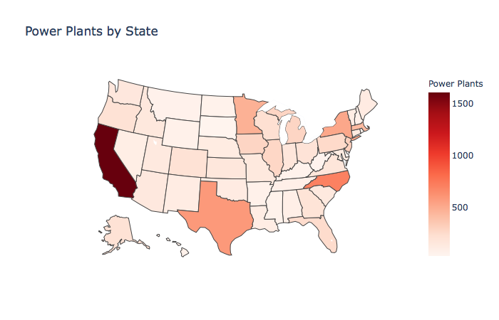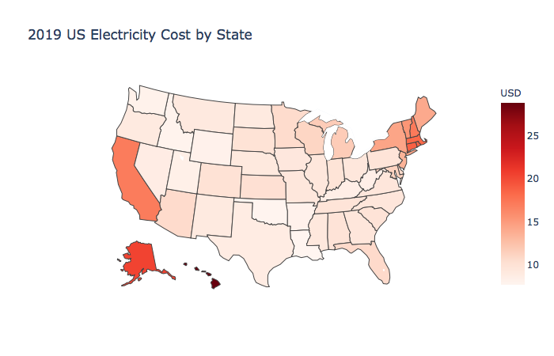

## Fig. 6 – Power plants by state (left) and electricity price (right)

When analyzed statistically, there was only a weak correlation, as show in Fig. 7 (right). **Overall, the number of power plants within a state does not affect the electricity price.**

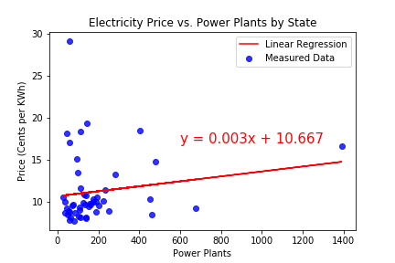

## Fig. 7 – Power plants distribution (left) and scatter plot of price vs power plants (right)

Data consideration regarding power plants: the data source (EIA.gov) does not make a distinction between the type of power plants nor the volume of power produced.

# Price vs Production

Fig. 8 shows the total generated electricity by state on the left.

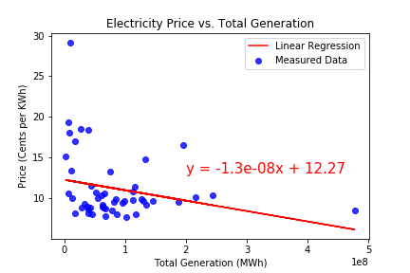

## Fig. 8 –Electricity generation (left) and scatter plot of price vs electricity generation (right)

Though many states have varying amounts of power plants available, the nature of geography does not correspond with a state’s borders. States will both produce AND consume electricity to and from other states.

Data consideration: these data points total energy from ALL sources, e.g. coal, natural gas, renewables, etc. What state uses what type of fuel varies wildly on geographic availability. As such, comparing total production versus electricity price should give the best analysis.

When compared statistically, there seems to be a weak correlation (r = 0.17) between Price vs Production, as can be seen in Fig. 8 (right). **Overall, production does not seem to affect the price within a state.**

# Price vs Overall Consumption

Intuitively, a state’s overall consumption of electricity across 4 categories (Residential, Industrial, Commercial, Transportation) would affect the state’s electricity price, under the premise that greater demand would normally lead to raising prices. Fig. 9 show the total electricity consumption by state.

## Fig. 9 –Electricity consumption by state

Data consideration regarding consumption: A state’s consumption was summed up from all categories; not every state had data points available for all the different categories. Which category would be consumed the most would vary wildly by state with more populous states having higher residential consumption, more industrious states having higher industry consumption, and so on.

Fig. 10 shows the scatterplot between price and electricity consumption. **Overall, there is a little correlation between electricity consumption and price.** Texas is on the far-right bottom corner and has a low cost regardless of how high the consumption. This is likely due to outside factors like California, who uses a tier system to price the electricity. The more you move up in the tier system, the more you pay. Which would explain why California has a higher population and a lower consumption than that of Texas.

## Fig. 10 –Scatter plot of price vs electricity consumption (right)

# Price vs Regulated/Non-regulated Sources

Each state handles how its customers are charged differently, but can broadly be categorized into regulated pricing (i.e. price OR provider is regulated by the state in some fashion) or non-regulated pricing (i.e. price/providers compete against each other on an open market).

For analysis, all the regulated pricing states were averaged together, the same was done for non-regulated pricing states. Fig. 11 shows the comparison of electricity price over the years of regulated and de-regulated states. When compared with each other, non-regulated pricing states tended to have higher prices, though overall it remained consistently within 2 cents per kWh when compared to regulated pricing states. Both consistently rose and fell through the years.

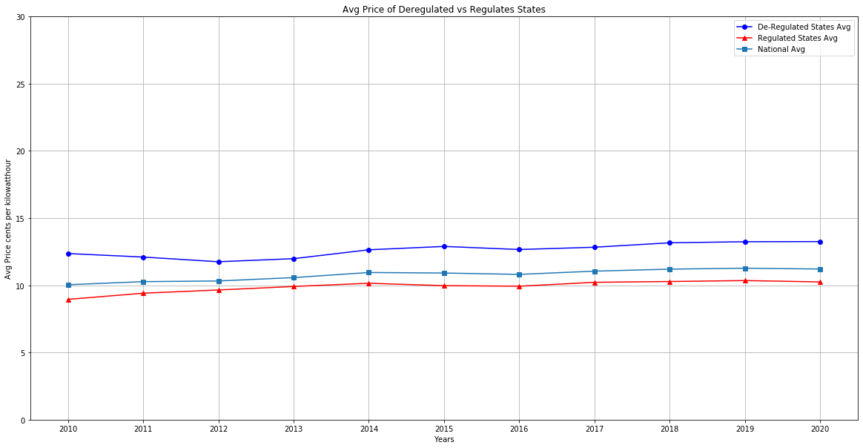

## Fig. 11 –Comparison of electricity price over the years of regulated and de-regulated states

When compared on a state by state basis, non-regulated pricing states tended to cluster together, and regulated pricing states tended to cluster together, as shown in Fig. 12. When looking at the *population density*, it seemed that states with lower population density seemed more often to have non-regulated pricing, while some of the higher densely populated states adopt regulated pricing.

As there seemed to be some difference in categorization, a 2-sample t-test was performed comparing the regulated pricing states vs. the non-regulated pricing states. Upon further analysis, there does appear to be a difference in the means between the two populations (*p-value* = .015), enough to conclude that **regulated pricing does influence the Electricity price overall.**

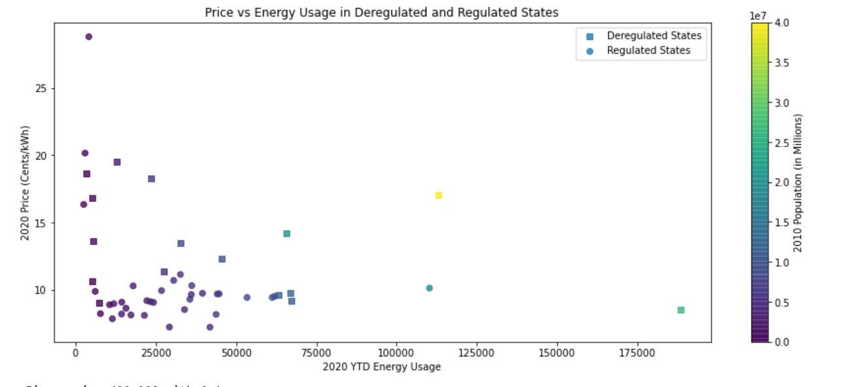

## Fig. 12 –Scatter plot of electricity price over the years of regulated and de-regulated states

*Ttest_indResult(statistic=2.552795913721027, pvalue=0.015751149234073045)*

Data consideration regarding this measurement: While the collected information set is large, its stratification along state lines reduced the population of this test to the 50 states. This was further reduced amongst the two categories, only 16 states are categorized as non-regulated, meaning overall the sample size for the test ending up being very small. Texas can be seen in the bottom right corner (green square). Texas is the largest energy producing and consuming state in the nation. Industry makes up about half of the energy consumed in the state. Texas has the lowest price for electricity for non-regulated states. Hawaii can be seen in the top left of this graph. It is due to its dependence on renewable energy as well as imported petroleum fuel which is used for electricity generation. It is also the only state to have a deadline to become completely renewable by 2045. All other states are clustered between 0 and 75,000 kWh and between 0 and 20 cents per kWh.

# Conclusion

Out of all the analyzed datasets, the only factor that showed statistically significant influence was the presence of regulated pricing. However, in practical considerations, the difference in pricing compared to a non-regulated state was never more than 2 cents. Given the interrelated nature of factors when such a broad topic, it is likely many of the examined data sets have knock-on effects within each other.

There are likely other many other confounding variables that would contribute to determining electricity price, of which the presence of regulation would be but one piece of a large, complicated overlapping puzzle.

# Data Sources

* U.S. Energy Information Administration (EIA)

<https://www.eia.gov/opendata/>

* United States Environmental Protection Agency

<https://www.epa.gov/energy/data-explorer>

* United States Census

<https://www.census.gov/data/datasets.html>